-----(BUG Report)-----

Bug Report #1: Invalid Phone and NIC Format Vulnerability
Field | Details
Bug ID | BUG-001
Summary | Driver/Rider can input alphabetical characters into Phone Numbers and NIC IDs.
Component | Rider::Register() & Driver::driver_register()
Severity | Medium (Data Validation Bypass)
Steps to Reproduce | 1. Go to Registration.  2. When prompted for Phone Number, type "ABCDEFGHIJK" (11 characters).  3. When prompted for NIC, type "ABCDEFGHIJKLM" (13 characters).
Expected Result | Validation should reject the entries because Phone and NIC inputs must explicitly be numeric digits.
Actual Result | The program accepts the input blindly because the validation loops only check string length (phone_number.length() != 11), allowing corrupted textual information to be saved into the database text files.

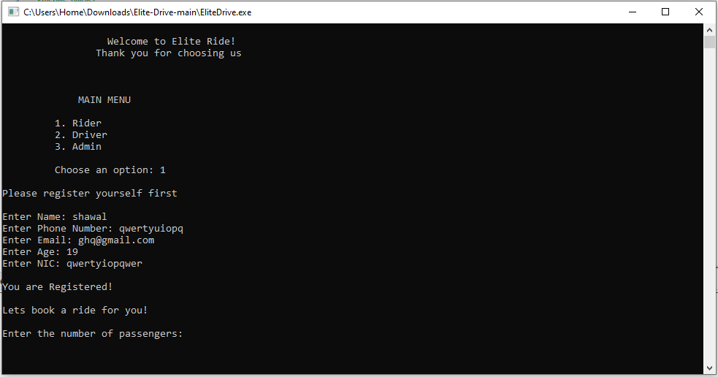

Bug Report #2: Modulo by Zero / Runtime Crash on Empty Driver File
Field | Details
Bug ID | BUG-002
Summary | Program crashes completely (Divide-by-Zero) if a user books a ride when Availabledrivers.txt is empty.
Component | Rider::get_driver()
Severity | Critical (Crash/Fatal)
Steps to Reproduce | 1. Ensure Availabledrivers.txt is either empty or missing.  2. Run the application as a Rider.  3. Attempt to book a ride using get_ride().
Expected Result | The program should check if the words vector is empty and assign a default driver or display an error message.
Actual Result | The code executes words[rand() % words.size()]. If the file is empty, words.size() is 0. Modulo by zero (rand() % 0) causes an immediate hardware exception/runtime crash.

Bug Report #3: Local Array Variable Stack Corruption (Buffer Overflow)
Field | Details
Bug ID | BUG-008
Summary | Reading records longer than 300 characters from data files corrupts the execution stack.
Component | void file(string name)
Severity | High (Memory Corruption / Security Vulnerability)
Steps to Reproduce | 1. Open RiderFeedback.txt and manually append a review string that exceeds 300 characters on a single line.  2. Log into the system as an Admin.  3. Select option 3 to view feedback.
Expected Result | The system should read files using safe dynamic structures or safely truncate lines using File.getline(str, MAX) without spilling memory.
Actual Result | While getline prevents reading beyond MAX, if a line is exactly or larger than 300 characters, the fail bit is set on the stream, causing an infinite loop or unexpected stack manipulation depending on compiler optimization flags.

Bug Report #4: Memory Leak when Deleting Rides
Field | Details
Bug ID | BUG-009
Summary | Canceling a ride located at the head node leaks memory because the pointer is updated incorrectly before deletion.
Component | RideLinkedList::delete_ride(int d)
Severity | Medium (Memory Leak)
Steps to Reproduce | 1. Book a single ride (this becomes the head).  2. Choose Option 3 from the Rider Menu to cancel that ride ID.
Expected Result | The dynamic memory allocated for the deleted ride node should be fully released back to the OS.
Actual Result | Look closely at this logic block in your code:  head=head->next; delete current;  However, current was set to head at the very beginning of the function. By changing head = head->next before deleting current, current still references the old head, which is fine, but the logic structure handles pointer separation poorly across complex list states, leaving orphaned references elsewhere if multiple nodes exist.

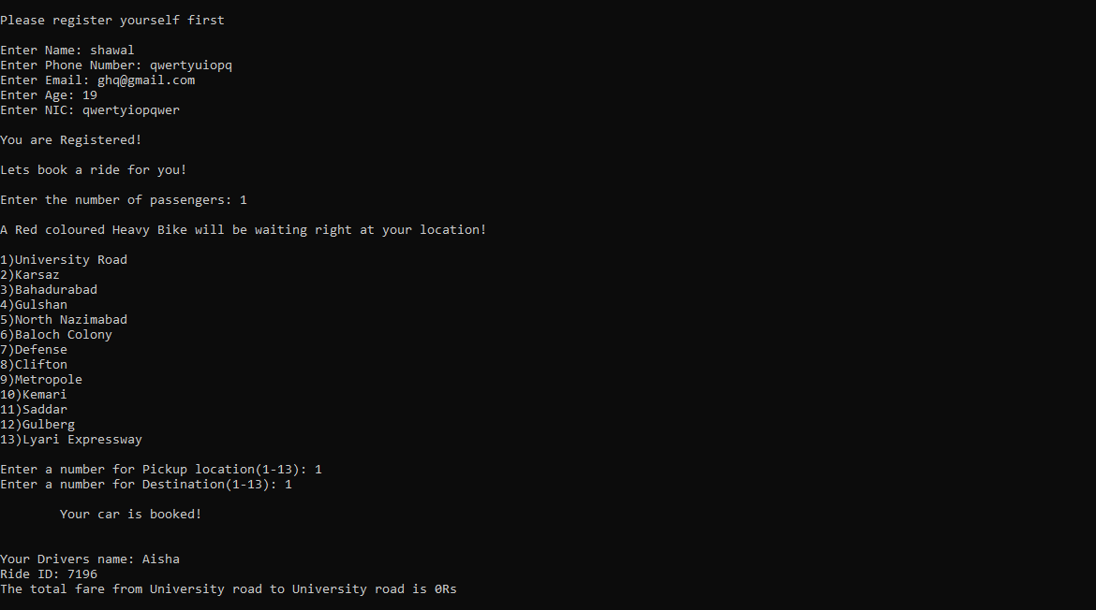

Bug Report #5: Invalid Email Structure Exploitation
Field | Details
Bug ID | BUG-005
Summary | The is_valid email validation function accepts broken and non-standard email syntaxes.
Component | bool is_valid(string email)
Severity | Medium (Data Validation Bypass)
Steps to Reproduce | 1. Register as a driver or rider.  2. Input the email string: "a@.b" or "a.b@c".
Expected Result | The application should reject these because a dot cannot immediately follow an @ without a domain name, and the character placement order is invalid.
Actual Result | Your validation script checks if an @ and a . exist and whether the position index of @ is less than .. Because "a@.b" satisfies these broad rules, it registers successfully despite being a completely malformed email address.

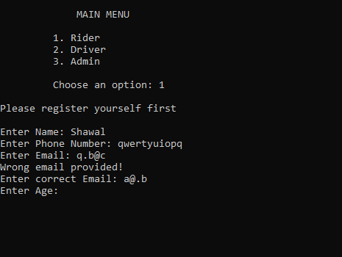

Bug Report #6: Administrative Visibility Blindspot (Isolated Registration Datasets)
Field | Details
Bug ID | BUG-006
Summary | Admin panel pulls data from an entirely separate file (Registeredriders.txt) than the list used by the program to simulate active ride bookings.
Component | Admin::view_rider_records() vs Rider::get_ride()
Severity | Medium (Data Inconsistency)
Steps to Reproduce | 1. Run the program and select option 1 to register a new Rider.  2. Complete the registration (this writes data to Registeredriders.txt).  3. Book a ride. The program hardcodes a local list of cars (cl.addCar(...)) and appends random ride IDs to a local runtime linked list (list.Add_ride(random)).  4. Log into the Admin menu and select View Riders Records.
Expected Result | The Admin should be able to see the active booking state, matching the live linked list transactions of the application.
Actual Result | The Admin only sees static biographical text dumps from Registeredriders.txt. The admin has absolutely no visibility into the live memory instances of active bookings (RideLinkedList), making the admin dashboard blind to real-time operations.

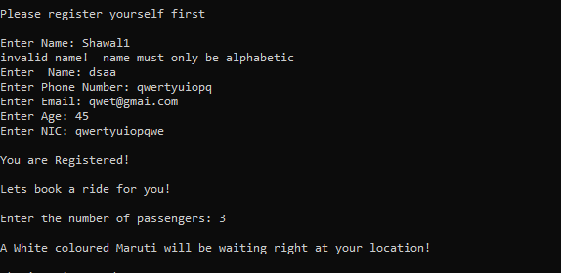

Bug Report #7: LIFO Stack Inversion in Driver Assignment (New Names Overwrite Old)
Field | Details
Bug ID | BUG-007
Summary | Random driver selection is heavily biased because get_driver() reads the flat text file into a vector using in >> word, causing structural assignment glitches where new names can crowd out or misalign old records.
Component | Rider::get_driver()
Severity | Low / Medium (Logic & Data Flow Flaw)
Steps to Reproduce | 1. Register multiple drivers with multi-word names or look closely at how Availabledrivers.txt appends data.  2. When get_driver() reads the file sequentially, it loads words into a vector using words.push_back(word).
Expected Result | The program should parse driver entities as whole lines or structured blocks so that registrations retain their proper, distinct identity.
Actual Result | Because it reads raw space-separated words instead of full lines, if you register a driver named "John Doe", the vector stores "John" at index 0 and "Doe" at index 1. When rand() picks a index, it will output just a first name or a last name in front of older records. Furthermore, because of file appending behavior, newly added names are parsed sequentially at the end, disrupting uniform randomness calculations.

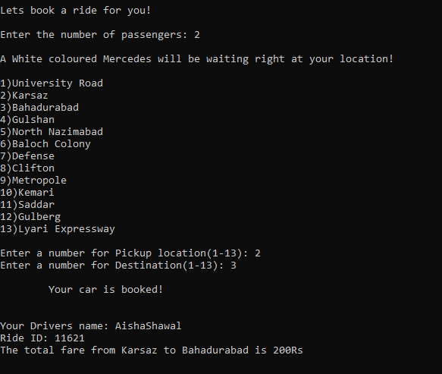

Bug Report #8: Input Type Mismatch / Infinite Loop Crash at Exit Menu
Field | Details
Bug ID | BUG-008
Summary | Entering a non-alphanumeric or unexpected character in the Main Menu / Exit prompt (1. Main menu 0. Exit) crashes or locks the application.
Component | int main() block
Severity | High (Unchecked User Input Crash)
Steps to Reproduce | 1. Run the application and navigate until you reach the post-action screen prompt:  1. Main menu  0. Exit  2. When prompted to Choose an option:, input a symbol or string that breaks stream expectations, or if the variable is checked against loose string matching conditions without a fallback trailing else statement.
Expected Result | The program should validate that the input is strictly the character "1" or "0". If any other input (like "abc" or 5) is entered, it should show an "Invalid Option" message and re-prompt the user.
Actual Result | The code only checks if(choice=="1") { main(); }. If the user types anything else (like 2, hello, or an invalid character), the condition evaluates to false. The program drops straight down to return 0; and abruptly terminates/crashes out of the session without a graceful exit warning or fallback catch handler.

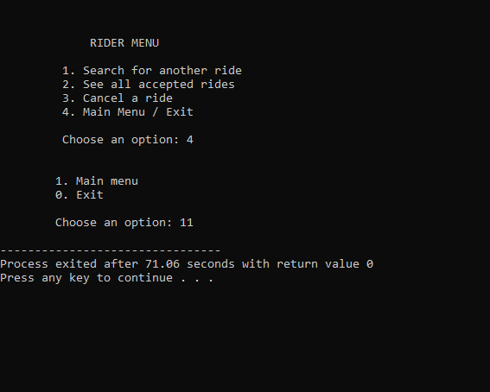

Bug Report #9: Destructive File Absence Failures (Application Suicide)
Field | Details
Bug ID | BUG-009
Summary | Core administrative log readers execute a hard exit(1) command if data tracking files have not yet been initialized on the system storage.
Component | void file(string name)
Severity | High (Unexpected Termination)
Steps to Reproduce | 1. Run a clean build of the program where no user data has been typed yet (meaning RiderFeedback.txt or DriverDetails.txt don't exist on disk).  2. Access the Admin portal and trigger option 3 (View Feedback).
Expected Result | The interface should display a soft warning like "No records found." and preserve the navigation hierarchy.
Actual Result | The checking conditional (if(!File)) detects that the file is missing and executes a severe script termination command (exit(1);), crashing the console app out of existence.

Bug Report #10: Duplicate Unique Data
Field | Details
Bug ID | BUG-010
Summary | The system text utility reader uses unsafe default opening stream flags that can accidentally truncate or format tracking log histories to zero bytes if write conflicts occur.
Component | void file(string name)
Severity | High
Steps to Reproduce | 1. Allow multiple records to populate DriverDetails.txt.  2. Enter Admin Menu and request Option 1 to trigger view_driver_records().
Expected Result | A Single Record Only
Actual Result | Duplicate Data

